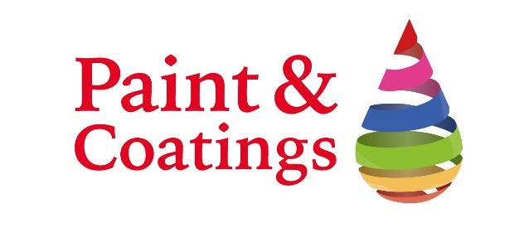
Paint & Coatings 2020
Advertising Form Return to:
Email: josezaragozano@step-exhibitions.com
Advertising in the Exhibition Catalogue

The official Paint & Coatings Exhibition Catalogue will be available to all visitors and exhibitors during the event. Please ensure you guarantee a premium position within the catalogue by returning this form promptly.

Company Name: |  | Stand No:
Address:
Contact:
Email: |  | Telephone:
Signed:

Advertising Rates I would like to book the following advertising (please tick relevant box):

□ 1/2 Page Full Colour 395€ + IVA
□ Full Page Full Colour 550€ + IVA
□ Inside Front Cover Full Colour 650€ + IVA
□ Inside Back Cover Full Colour 650€ + IVA
□ Outside Back Cover Back Cover 715€ + IVA

